**Practice Assessment for Exam AI-102: Designing and Implementing a Microsoft Azure AI Solution**

Top of Form

Question 1 of 50

You are building a solution that uses Azure AI Search.

You need to define the field attributes for a field where the search results will include a hit count by category.

Which attribute should you assign to the field?

Select only one answer.

**facetable**

filterable

key

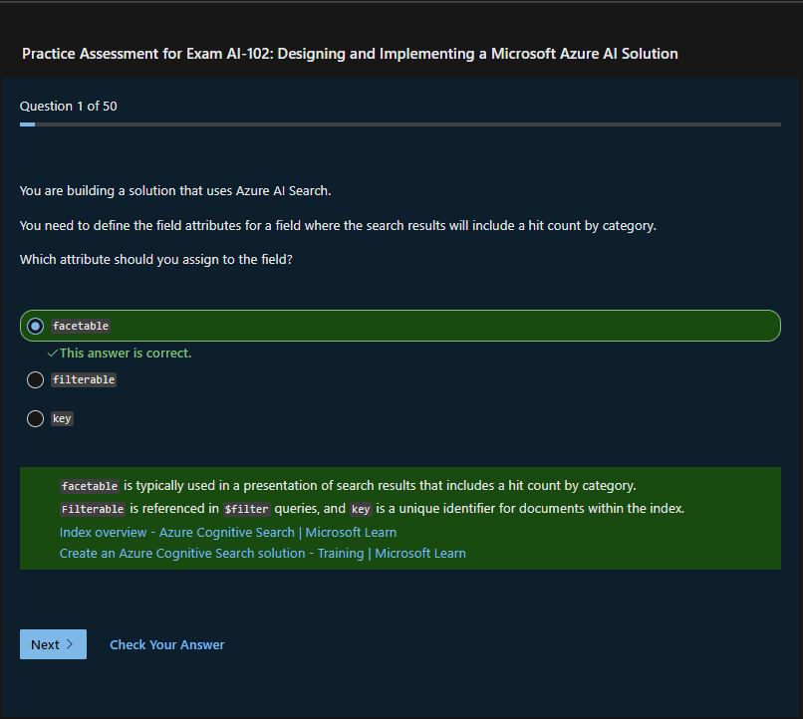Bottom of Form